CSA1708-ARTIFICIAL INTELLIGENCE
LAB EXPERIMENTS
Program 5 : Python Program to Solve Missionaries and Cannibals Problem
Aim
To write a Python program that uses Breadth-First Search to safely move three missionaries and three cannibals across a river in a boat that carries up to two people.
Algorithm
1. Represent a state by the number of missionaries and cannibals on the left bank and the boat side.
2. Start with all people and the boat on the left bank.
3. Generate crossings carrying one or two people.
4. Reject states where the number of cannibals exceeds missionaries on either bank, unless there are no missionaries there.
5. Use BFS and record each state's previous state.
6. When the goal state is reached, display the path.
Program
from collections import deque

moves = [(1, 0), (2, 0), (0, 1), (0, 2), (1, 1)]
start = (3, 3, 0)
goal = (0, 0, 1)
queue = deque([start])
parent = {start: None}

while queue:
state = queue.popleft()
if state == goal:
break

m, c, side = state
for dm, dc in moves:
if side == 0:
next_state = (m - dm, c - dc, 1)
else:
next_state = (m + dm, c + dc, 0)

ml, cl, _ = next_state
mr, cr = 3 - ml, 3 - cl
safe = (0 <= ml <= 3 and 0 <= cl <= 3
and (ml == 0 or ml >= cl)
and (mr == 0 or mr >= cr))

if safe and next_state not in parent:
parent[next_state] = state
queue.append(next_state)

if goal in parent:
path = []
state = goal
while state is not None:
path.append(state)
state = parent[state]

print("Solution path:")
for state in reversed(path):
print(state)
else:
print("No solution found.")
Program Execution
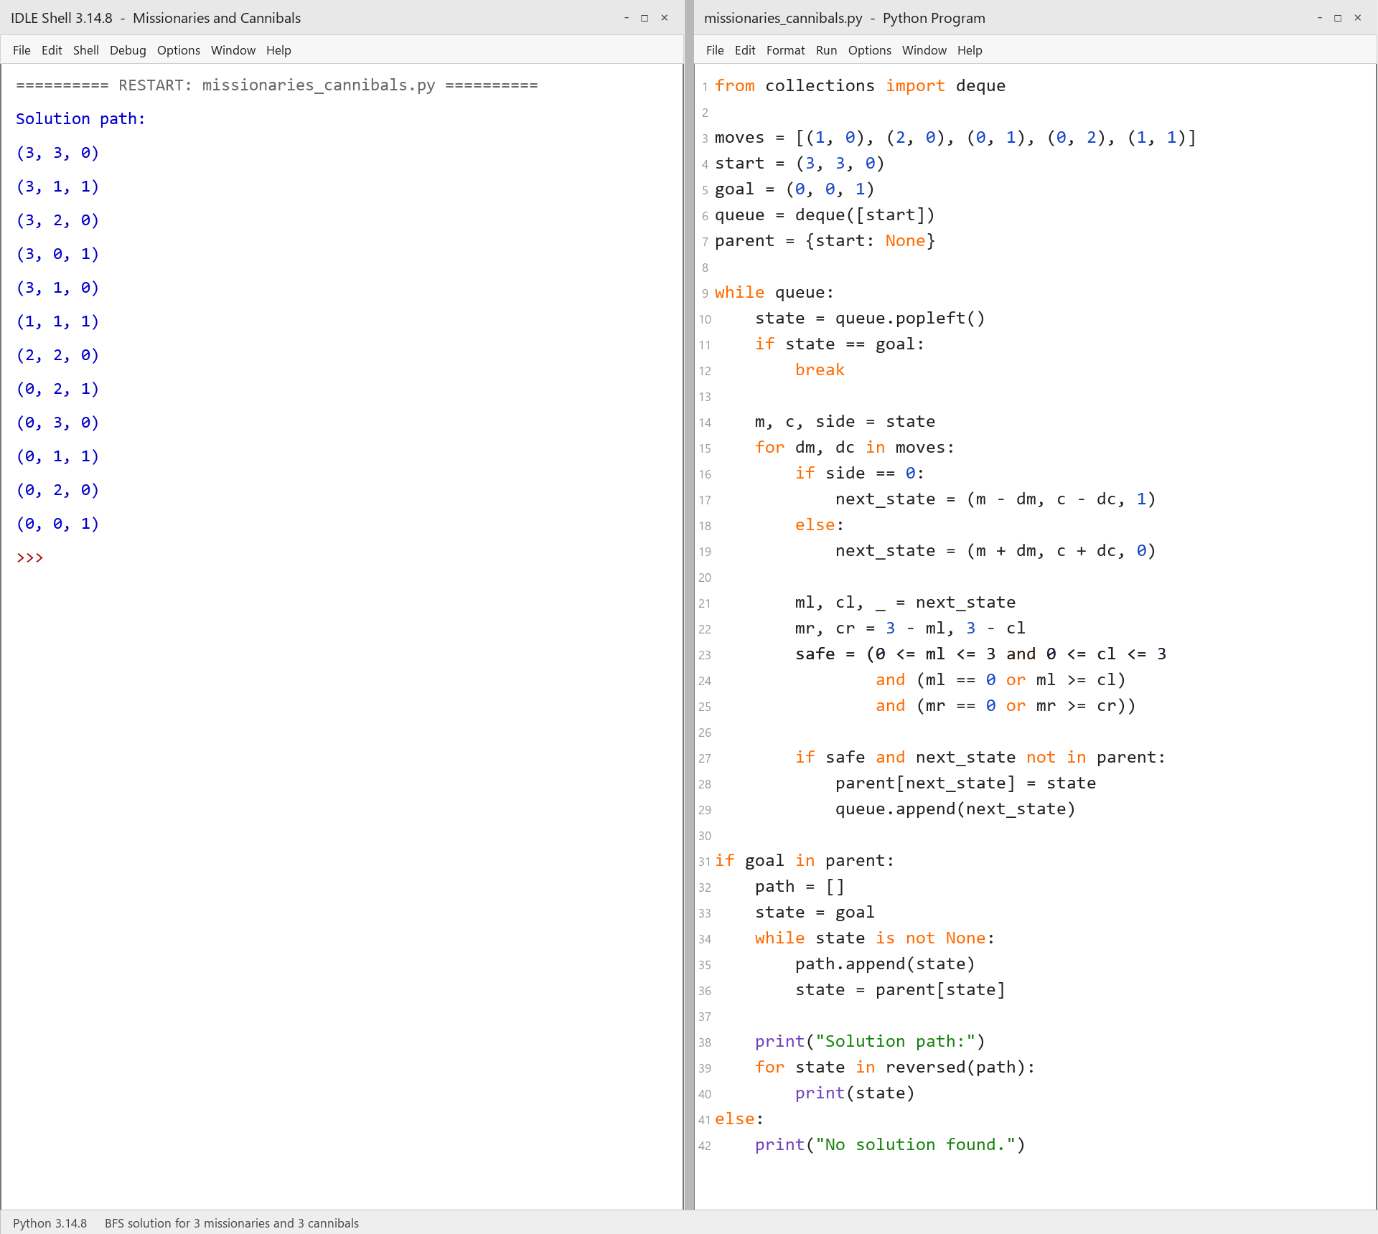
RESULT
Thus, the Missionaries and Cannibals problem was solved successfully using Python and BFS.

